How to create Azure container registry (ACR) and push image docker image to that or can push local image.

1. Create ACR

Go to azure portal and search for container registry.

Go for create define name. name should be universal unique. Choose other configuration such as RG, pricing plan.

In Networking allow public access and disable customer managed tag. In standard pricing by default it’s disabled.

Create repository.

1. Connect to repository

Go to powershell and run below command

* az acr login --name myfirsttestacr1
* az acr login –name nameOFyourContainer



1. The image we want to push to ACR that image should be on the server from where we connected to ACR.

Run below command to check all the images present on server

* docker images

If the required image is not present locally and present on docker pull the image.

* docker pull image-name:tag

if the tag is not defined it will pull the latest

* docker pull hiparthapanda297/ecomm-img:latest

once the image is pulled successfully. Can run “docker images” and check.

1. Once the image is available locally, you can tag it for your Azure Container Registry (ACR)

Tagging an image for your Azure Container Registry (ACR) essentially prepares the image for upload to ACR by giving it a new name that includes the ACR’s URL. This helps Docker know where to push the image.

When you tag an image, you give it a new name that includes the registry URL.

Run the below cmd to tag image

* docker tag hiparthapanda297/ecomm-img myfirsttestacr1.azurecr.io/ecomm-img

The new tag includes the ACR URL (myfirsttestacr1.azurecr.io), which tells Docker where to push the image. This is necessary because Docker needs to know the destination registry.

1. Once the image is tagged and prepared for push to ACR, push the image to ACR repository.

* docker push myfirsttestacr1.azurecr.io/ecomm-img

1. Verify the image from ACR

Go to ACR and go to repository  
  
Go to image and choose Tag, which image version we want to use. We will get pull cmd to use the image and also image name with tag to use.

Create a container instance and test the image.

We can use the image in multiple place such as deployment file for AKS, for app service image or can use for creating container instance (ACI).

Azure container instance is a service which is used for easy creating a container and run.

Rather then creating a vm installing docker or any other containerized software. Create container and run.

We can directly for container instance service. Here, the vm or h/w taken care by Microsoft. We can just create a container and run quickly. It will be managed by azure.

Containers are logically isolated. This container will have public ip and we can directly use the container.

1. Create container instance

Provide required configuration details. Choose SKU type, choose the image source

* Quickstart images are preconfigured images by Microsoft to build fast and test. Those basically display welcome page.
* Azure container registry this allow us to choose image from ACR.
* Other registry allow us to choose image from other registry such as docker.  
    
  A screenshot of a computer

  Description automatically generated

While choosing registry, it must have admin user enabled. Else we will see error.

Microsoft Doc to enable admin to the registry –

[Azure Container Registry Authentication Options Explained - Azure Container Registry | Microsoft Learn](https://learn.microsoft.com/en-gb/azure/container-registry/container-registry-authentication?tabs=azure-cli#admin-account)

We can either run the command from cloud shell to enable admin or can do it by az cli. Or from Azure Portal.

By cloudshell-

* Update-AzContainerRegistry -Name <acrName> -ResourceGroupName myResourceGroup -EnableAdminUser

By AZ cli

* az acr update -n <acrName> --admin-enabled true

if need to select RG where ACR is

* az acr update -n myfirsttestacr1 --resource-group RG104Test --admin-enabled true

By Azure Portal

You can enable the admin user in the Azure portal by navigating your registry, selecting **Access keys** under **SETTINGS**, then **Enable** under **Admin user**.

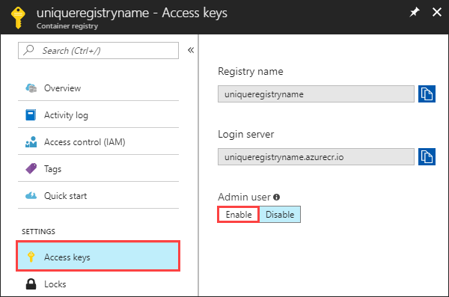

Once Admin access enabled verify it.

Once done, Go back to create and choose registry, image and tag.

We can also choose size.

Configure networking

Choose the port to run the container.

Provide other details such as monitoring, tag etc. and create.

1. Once it’s created verify the application access by container public ip

Access the site

